Mozambique

## GNI per capita and development level

The data set shows the GNI per capita and development level of the country each year.

## # A tibble: 19 x 5  
## country iso3c date GNIperCapita devCategory  
## <chr> <chr> <dbl> <dbl> <chr>   
## 1 Mozambique MOZ 1996 227. Low Income   
## 2 Mozambique MOZ 1998 264. Low Income   
## 3 Mozambique MOZ 2000 280. Low Income   
## 4 Mozambique MOZ 2002 301. Low Income   
## 5 Mozambique MOZ 2003 339. Low Income   
## 6 Mozambique MOZ 2004 356. Low Income   
## 7 Mozambique MOZ 2005 361. Low Income   
## 8 Mozambique MOZ 2006 374. Low Income   
## 9 Mozambique MOZ 2007 397. Low Income   
## 10 Mozambique MOZ 2008 417. Low Income   
## 11 Mozambique MOZ 2009 444. Low Income   
## 12 Mozambique MOZ 2010 457. Low Income   
## 13 Mozambique MOZ 2011 485. Low Income   
## 14 Mozambique MOZ 2012 512. Low Income   
## 15 Mozambique MOZ 2013 534. Low Income   
## 16 Mozambique MOZ 2014 553. Low Income   
## 17 Mozambique MOZ 2015 569. Low Income   
## 18 Mozambique MOZ 2016 573. Low Income   
## 19 Mozambique MOZ 2017 571. Low Income

## GDP growth and economic growth classification

The data set shows the GDP growth and the ecomic growth classification of the country each year.

## # A tibble: 19 x 5  
## country iso3c date GDPannualGrowthRate GDPgrowthCategory4  
## <chr> <chr> <dbl> <dbl> <fct>   
## 1 Mozambique MOZ 1996 11.2 fast growth   
## 2 Mozambique MOZ 1998 9.93 fast growth   
## 3 Mozambique MOZ 2000 1.18 slow growth   
## 4 Mozambique MOZ 2002 9.29 fast growth   
## 5 Mozambique MOZ 2003 6.88 fast growth   
## 6 Mozambique MOZ 2004 7.92 fast growth   
## 7 Mozambique MOZ 2005 6.65 fast growth   
## 8 Mozambique MOZ 2006 9.69 fast growth   
## 9 Mozambique MOZ 2007 7.73 fast growth   
## 10 Mozambique MOZ 2008 7.32 fast growth   
## 11 Mozambique MOZ 2009 6.32 fast growth   
## 12 Mozambique MOZ 2010 6.50 fast growth   
## 13 Mozambique MOZ 2011 7.42 fast growth   
## 14 Mozambique MOZ 2012 7.26 fast growth   
## 15 Mozambique MOZ 2013 6.96 fast growth   
## 16 Mozambique MOZ 2014 7.40 fast growth   
## 17 Mozambique MOZ 2015 6.72 fast growth   
## 18 Mozambique MOZ 2016 3.82 moderate growth   
## 19 Mozambique MOZ 2017 3.74 moderate growth

## Development trend

The plot shows the development trend of the country.

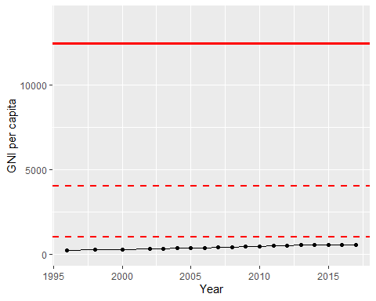

GNI Per Capita Trend